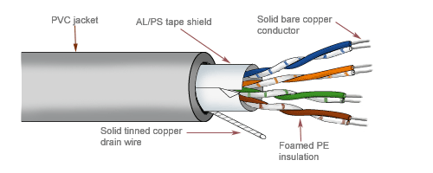**Twisted pair.**

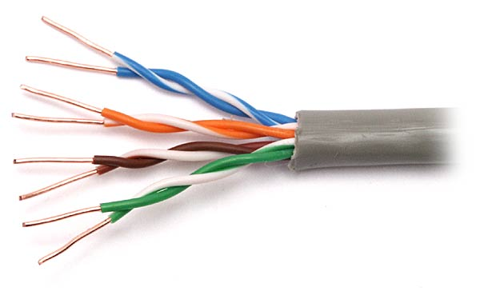

**Unshielded Twisted pair Shielded Twisted pair**

|  |
| --- |
| **Data transmission rate, range and type:**  Twisted pair can be used for transmitting either analog or digital signal and frequency range for twisted pair cable is 100 Hz to 5 Mhz. @ 4-16 Mbps |

|  |
| --- |
| **Advantages:**  1. It can be used to carry both analog and digital data.  2. It is relatively easy to implement and terminate.  3. It is the least expensive media of transmission for short distances.  4. If portion of a twisted pair cable is damaged it does not affect the entire network |

|  |
| --- |
| **Disadvantages:**  1.It offers poor noise immunity as a result signal distortion is more?  2. Attenuation is very high.  3. It supports lower bandwidth as compared to other Medias. It supports 10 mbps up to a distance of 100 meters on a 10BASE-T.  4. It offers very poor security and is relatively easy to tap.  5. Being thin in size, they are likely to break easily. |

|  |
| --- |
| **Application:**   1. The most common application of twisted pair cable is in telephone system. 2. In the local loop. 3. In the DSL line (ADSL) 4. Local area networks such as 10 Base-T and 100 Base-T. Use the twisted pair cables. |

**Coaxial Cable.**

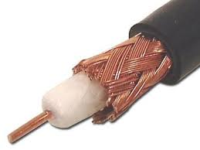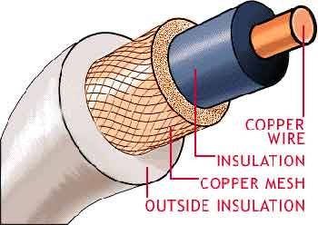

|  |
| --- |
| **Data transfer rates, range and type:**  Rate: 10 Mbps.  Range i.e. Bandwidth: 300-3400 Hz  Type of data signals: Both analog and digital signals are transmitted. |

|  |
| --- |
| Advantages:  1. It offers higher bandwidth as compared to twisted pair cable and can span longer distances.  2. Because of better shielding in coaxial cable, loss of signal or attenuation is less.  3. Better shielding also offers good noise immunity.  4. It is relatively inexpensive as compared to optical fibres |

|  |
| --- |
| **Disadvantages of Coaxial Cables:**  1. It is usually more expensive than twisted pair. |

|  |
| --- |
| **Applications of Co-axial Cables**:   1. Analog telephone networks. 2. Digital telephone network. 3. Cable TV 4. Traditional Ethernet LANs 5. Digital transmission 6. Thick Ethernet. |

**Fibre Optic Cable.**

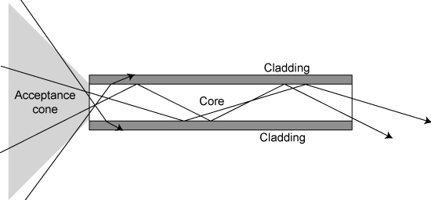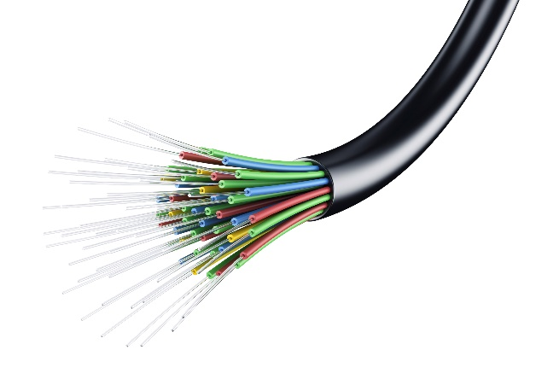

|  |
| --- |
| **Data transfer rates and bandwidth:**  Rate: up to 10 gbps.  Bandwidth: usually 500-1000 MHz over a length of 1 km. A single optical fibre can carry over 3,000,000 full-duplex voice calls or 90,000 TV channels. |

|  |
| --- |
| **Advantages:**   * High bandwidth & large capacity: transmit large amount of information; over 2million simultaneous telephone conservations on two optical fibres, and a optical cable contains over 200 optical fibres. For microwave or satellite links, only 2000 conversations * Small size, light weight, flexible, easy installation * Immunity to interference: not effected by electrical magnetic interference (EMI) * Free of cross talk between fibres |

|  |
| --- |
| **Disadvantages**:   * Electrical-to-optical conversion: signal must be converted to light wave and back to electrical signal. Cost on electronics in all applications * Physical right of way is required for the cable installation * Optical fibre is predominantly silica glass, special techniques are needed for engineering installation of the fibre cable * repairs: difficult to repair broken optical cable * Network interface card and cabling is expensive   Connection to network is difficult. |

|  |
| --- |
| **Applications:**  Optical fibre is used by many telecommunications companies to transmit telephone signals, Internet communication, and cable television signals |

**Radio Waves**

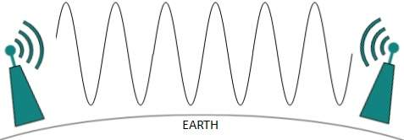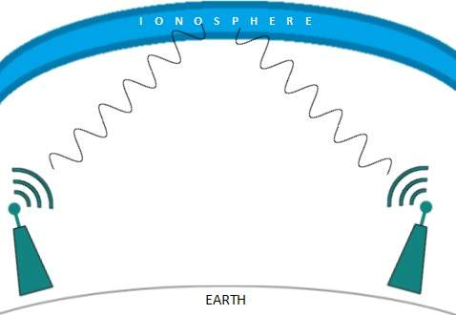

|  |
| --- |
| Radio frequency is easier to generate and because of its large wavelength it can penetrate through walls and structures alike. Radio waves can have wavelength from 1 mm – 100,000 km and have frequency ranging from 3 Hz (Extremely Low Frequency) to 1 GHz (Extremely High Frequency). Radio frequencies are sub-divided into six bands. |

|  |
| --- |
| **Advantages:**   * Not affected by interstellar dust. * It offers mobility. * Ease of communication over difficult terrain. * Low energy cost. * Low noise background. * Travel at speed of light(unlike guided media) |

|  |
| --- |
| **Disadvantages:**   * Radio wave communication is an insecure mode of communication. * Radio wave propagation is susceptible to weather effects like rain, thunder storm, etc |
| **Features:**   * Radio waves use omnidirectional antennas that send out signals in all directions. * Based on the wavelength, strength, and the purpose of transmission, we can have severaltypes of antennas. * Radio waves, particularly those waves that propagate in the sky mode, can travel long distances. This makes radio waves a good candidate for long-distance broadcasting such as AM radio. * Radio waves, particularly those of low and medium frequencies, can penetrate walls.This characteristic can be both an advantage and a disadvantage. It is an advantagebecause, for example, an AM radio can receive signals inside a building |

**Micro Waves**

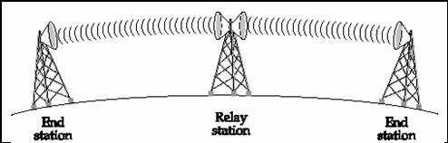

|  |
| --- |
| **Features:**   * Microwaves need unidirectional antennas that send out signals in one direction. * Microwave antennas concentrate the waves making a beam of it. As shown in picture above, multiple antennas can be aligned to reach farther. Microwaves have higher frequencies and do not penetrate wall like obstacles.. * Microwave transmission depends highly upon the weather conditions and the frequency it is using |

|  |
| --- |
| **Advantages:**   * It proves to be cheaper than digging trenches for laying cables and maintaining repeaters and cables if they get broken because of variety of causes. * It offers ease of communication over difficult terrain. * Ability to communicate over oceans (not possible with radio waves) * Wide bandwidth. * Multi-channel transmission. * Requires fewer amplifiers or repeaters. |

|  |
| --- |
| **Disadvantages:**   * Insecure mode of communication. * Requires that the antennas (the receiver and the transmitter) be in line of sight. * Expensive towers and repeaters required. * Subject to interference such as airplanes (physical moving barrier) or rain (weather effects) .   Frequency bands are regulated by the government or a competent authority |

|  |
| --- |
| **Applications**  Microwaves, due to their unidirectional properties, are very useful when unicast (one-to-one) communication is needed between the sender and the receiver. They are used in cellular phones, satellite networks and wireless LANs |

**Infrared**

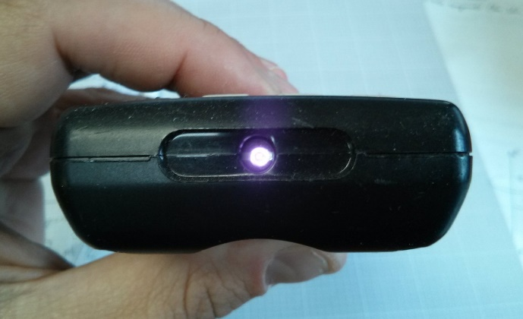 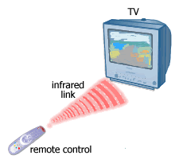

|  |
| --- |
| **Features:**   * Infrared waves, with frequencies from 300 GHz to 400 THz (wavelengths from 1 mm to 770 nm), can be used for short-range communication. * Infrared waves, having high frequencies, cannot penetrate walls. This advantageous characteristic prevents interference between one system and another; a short-range communication system in one room cannot be affected by another system in the next room. |

|  |
| --- |
| **Advantages:**   * Simple, cheap and easy to configure devices and circuits required for its setup. * No costly licences needed. * Simple shielding and confining of signals easily possible. |

|  |
| --- |
| **Disadvantages:**   * Interference by sunlight, heat, and other sources of IR give rise to noise in signal. * Also IR is easily absorbed by a variety of materials * Low usable bandwidth. |

|  |
| --- |
| **Applications:**   * Infrared waves are used in communication between devices like the keyboard, printers, etc * Also IR is used in remote controlled devices where the remote generate the IR radiations |